**Lab 15: Patching EXEs with Ollydbg**

**Patching an EXE**

Check hash file exe

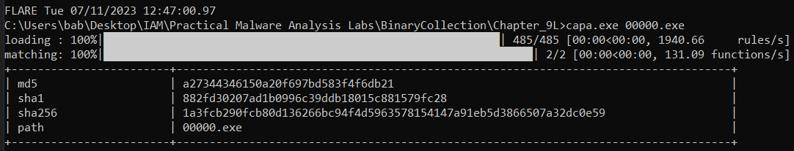

**Running the EXE**

Chạy thử file exe này.

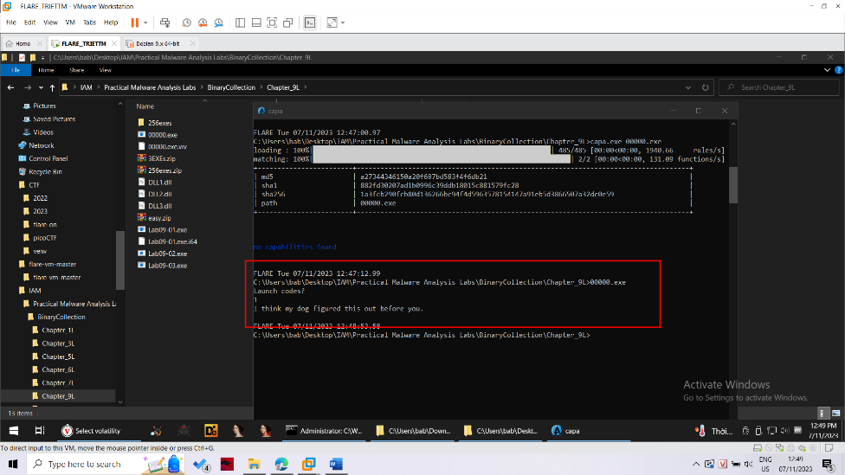

**Examining the EXE with Ollydbg**

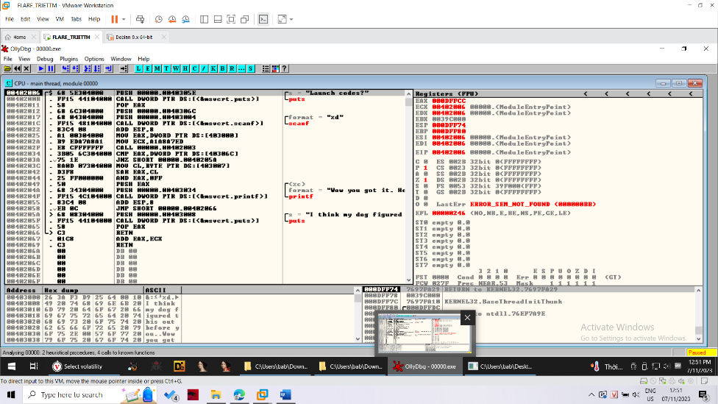

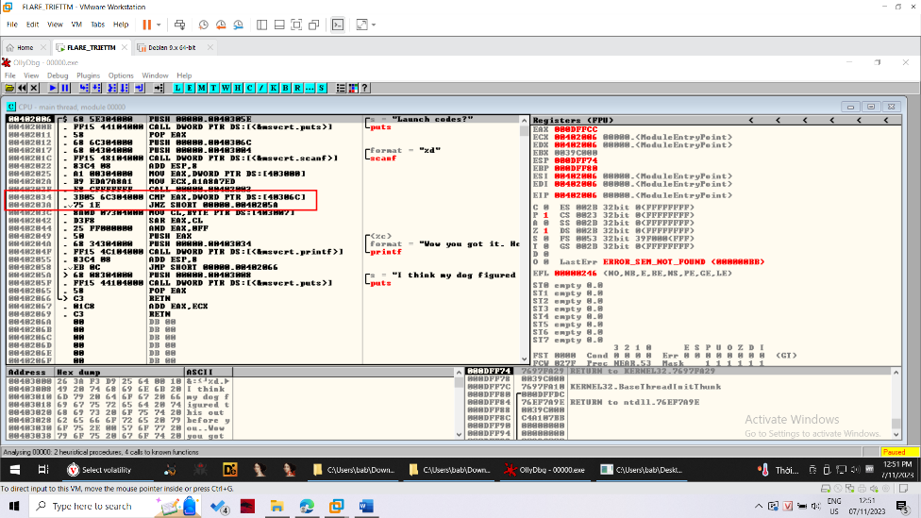

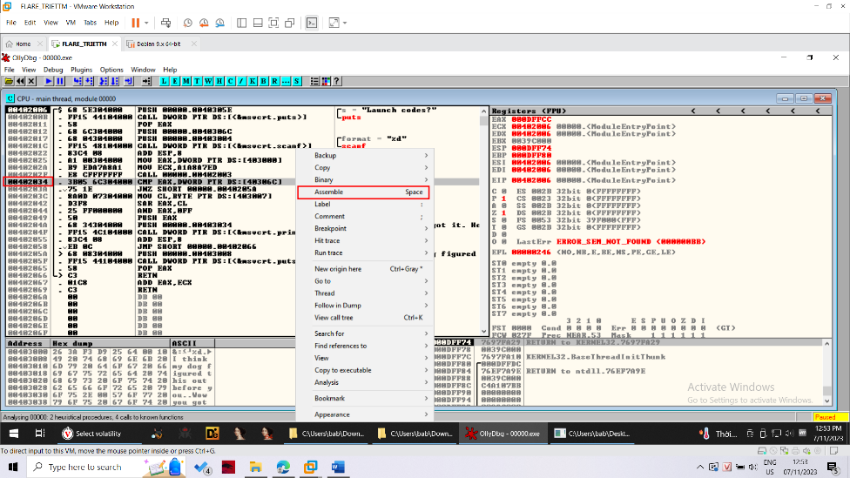

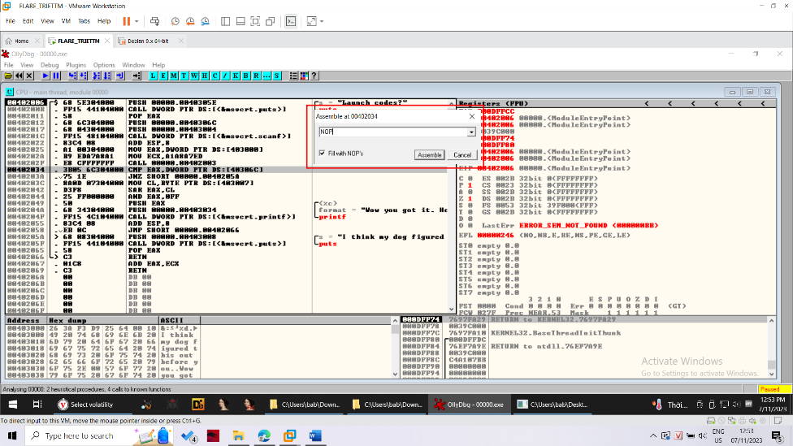

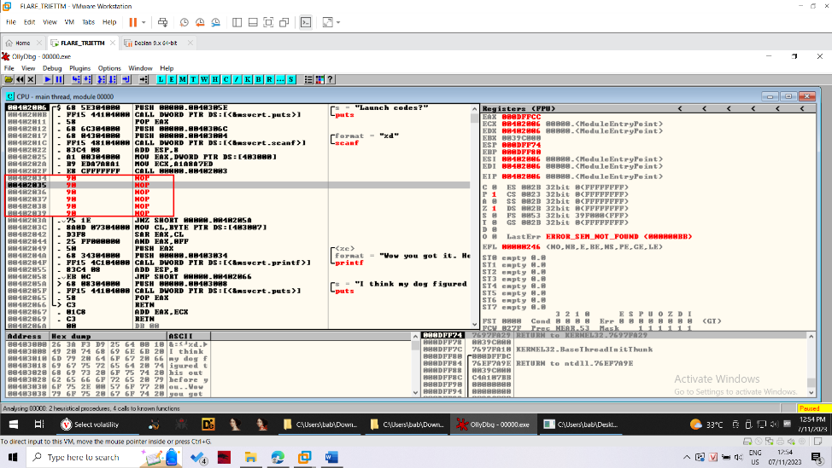

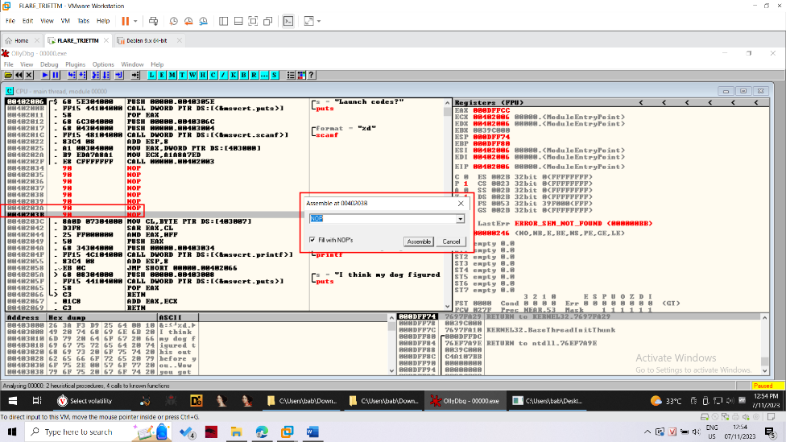

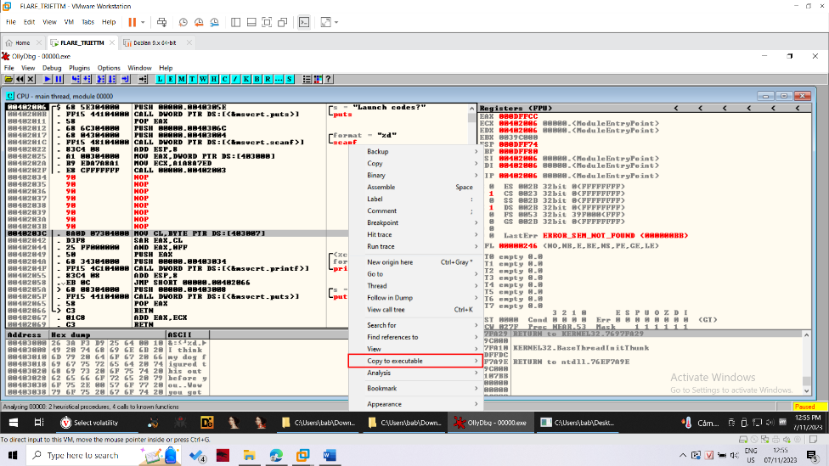

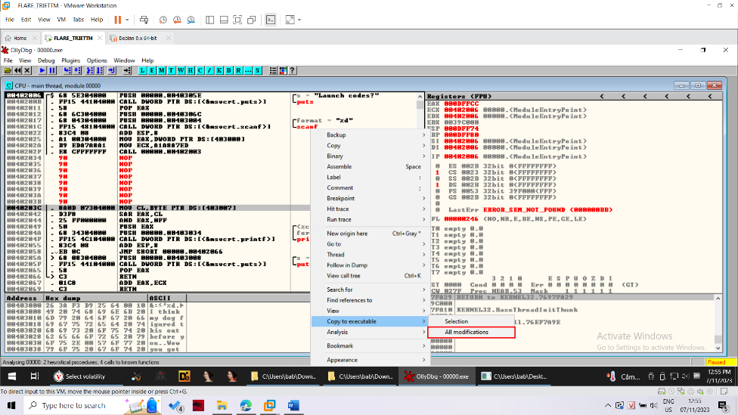

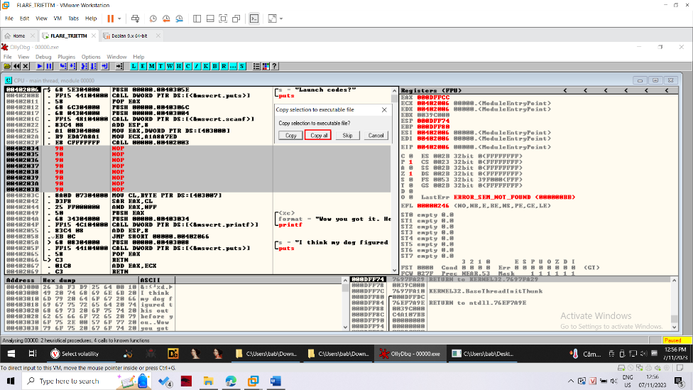

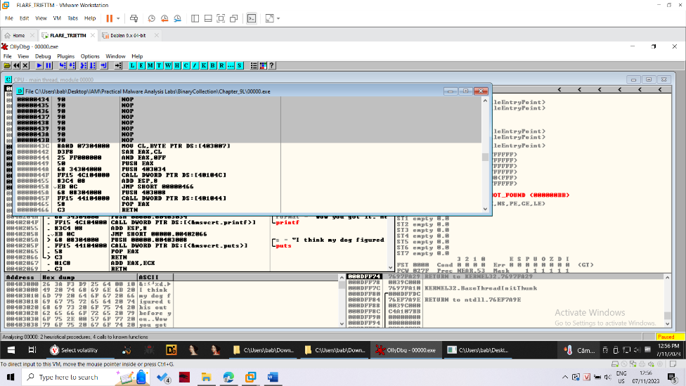

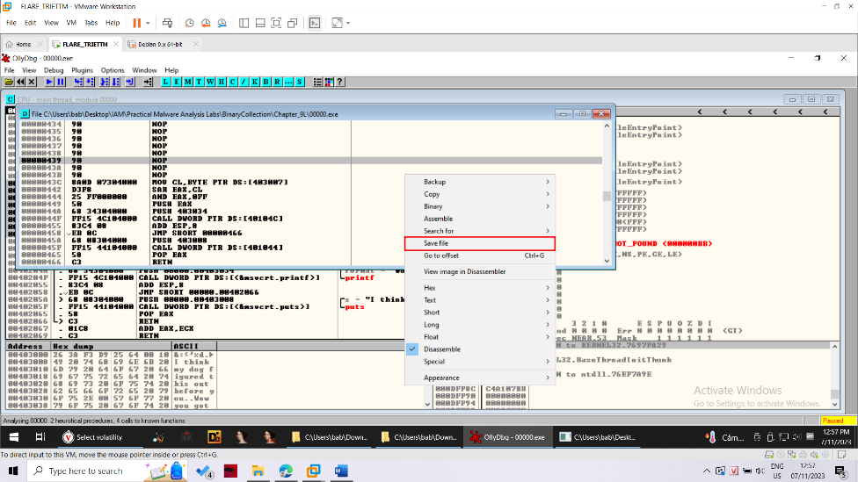

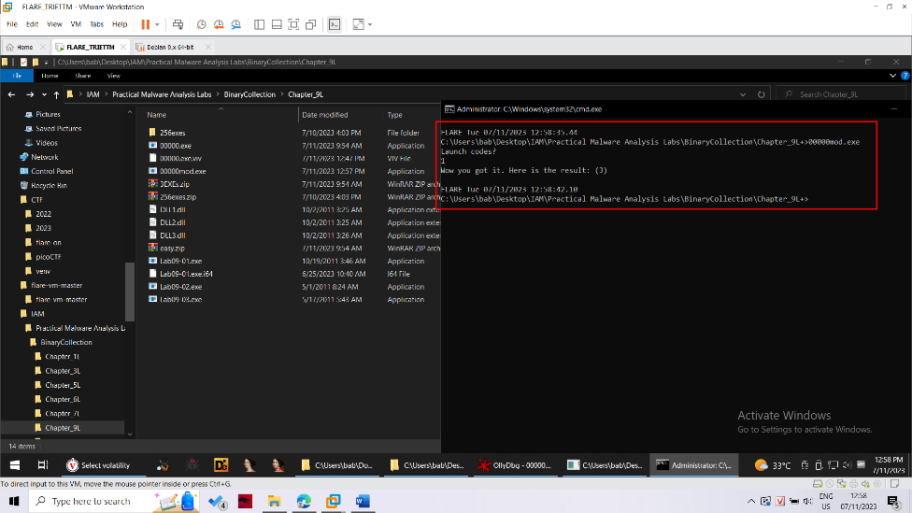

**Checking the Hash**

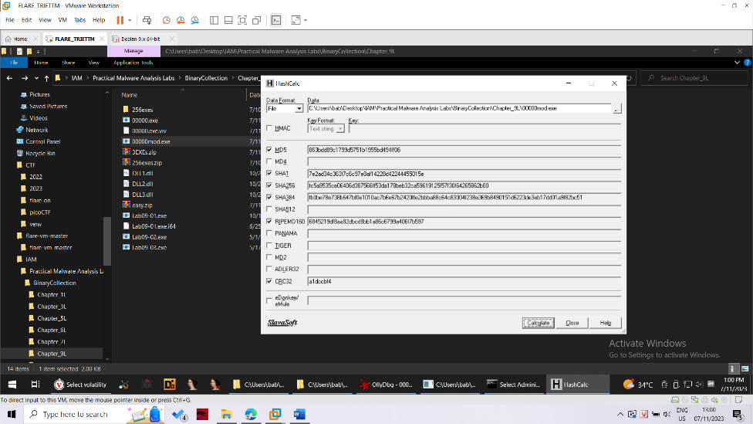

**Patching Three EXEs**

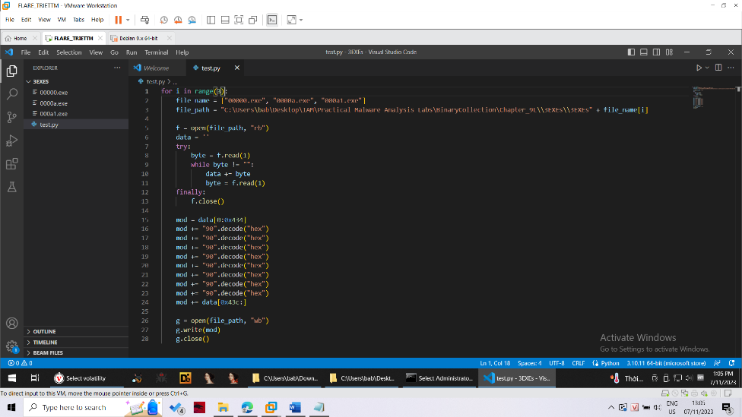

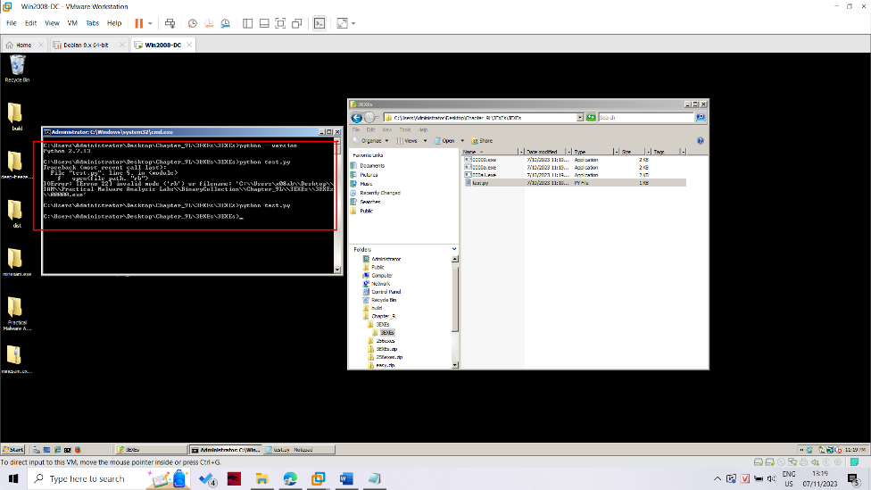

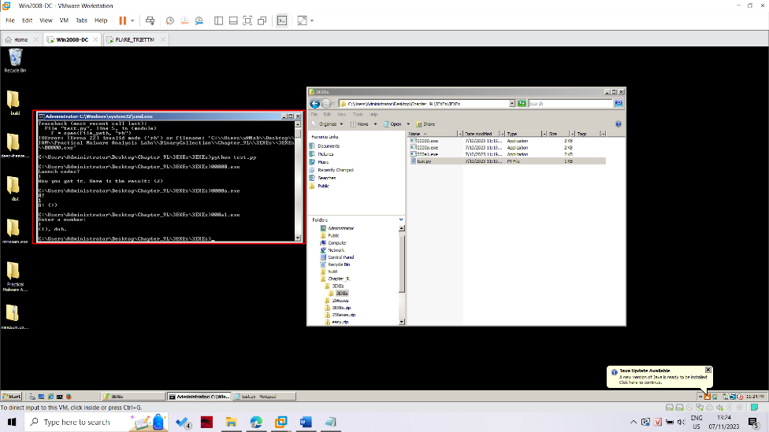

**Patching 256 EXEs**

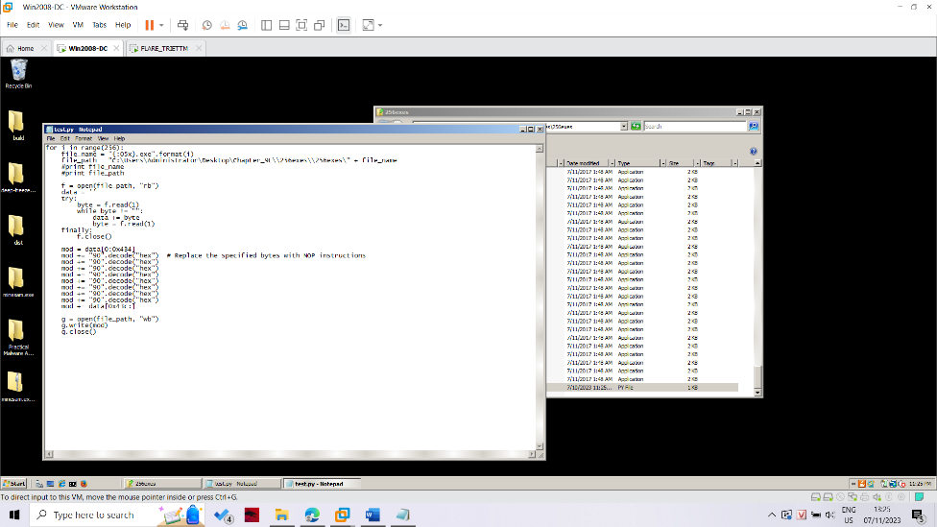

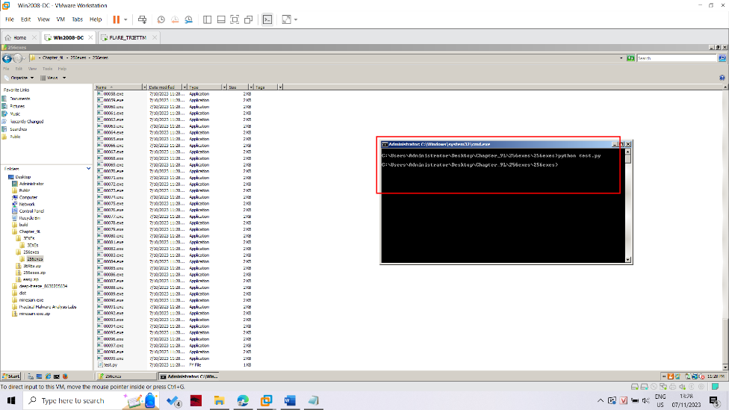

Because 256 file have the different offset, so we have to scripting a bit difficult to patch. I use following script

import os

import pefile

from capstone import *

from capstone.x86 import *

dir = "C:\\Users\\bab\\Desktop\\256exes\\"

for filename in os.listdir(dir):

    print(filename)

    file = pefile.PE(filename)

    code_section = None

    for section in file.sections:

        if section.Characteristics & pefile.SECTION_CHARACTERISTICS["IMAGE_SCN_MEM_EXECUTE"]:

            code_section = section

            break

    CODE_BASE = code_section.VirtualAddress

    CODE_SIZE = code_section.SizeOfRawData

    code_data = file.get_memory_mapped_image()[CODE_BASE : CODE_BASE + CODE_SIZE]

    md = Cs(CS_ARCH_X86, CS_MODE_32)

    for insn in md.disasm(code_data, CODE_BASE):

        if( insn.mnemonic == "cmp" ):

            patched_code = b"\x90\x90\x90\x90\x90\x90\x90\x90"

            file.set_bytes_at_rva(insn.address, patched_code)

            break

    file.write("patched_" + filename)

Using above script then all file will corectly patched.